ish¿u ysñlï weúßKs $ All Rights Reserved

St. Peter's College

St. Peter's College

St. Peter's College

புனித பேதுரு கல்லூரி

புனித பேதுரு கல்லூரி

புனித பேதுரு கல்லூரி

புனித பேதுரு கல்லூரி

புனித பேதுரு கல்லூரி

புனித பேதுரு கல்லூரி

புனித பேதுரு கல்லூரி

புனித பேதுரு கல்லூரி

Ydka; mS;r úÿy,

Ydka; mS;r úÿy,

Ydka; mS;r úÿy,

Ydka; mS;r úÿy,

Ydka; mS;r úÿy,

Ydka; mS;r úÿy,

Ydka; mS;r úÿy,

Ydka; mS;r úÿy,

Ydka; mS;r úÿy,

Ydka; mS;r úÿy,

St. Peter's College

St. Peter's College

St. Peter's College

St. Peter's College

St. Peter's College

St. Peter's College

St. Peter's College

St. Peter's College

St. Peter's College

St. Peter's College

புனித பேதுரு கல்லூரி

புனித பேதுரு கல்லூரி

புனித பேதுரு கல்லூரி

புனித பேதுரு கல்லூரி

புனித பேதுரு கல்லூரி

புனித பேதுரு கல்லூரி

புனித பேதுரு கல்லூரி

புனித பேதுரு கல்லூரி

Ydka; mS;r úÿy,

Ydka; mS;r úÿy,

Ydka; mS;r úÿy,

Ydka; mS;r úÿy,

Ydka; mS;r úÿy,

Ydka; mS;r úÿy,

Ydka; mS;r úÿy,

Ydka; mS;r úÿy,

Ydka; mS;r úÿy,

Ydka; mS;r úÿy,

St. Peter's College

St. Peter's College

St. Peter's College

St. Peter's College

St. Peter's College

St. Peter's College

St. Peter's College

41

**I,II**

**wmrÈ. ix.S;h**

**Western Music**

**meh 02**

**Two Hours**

**10 fY%aKsh – m<uq jdr we.hsu - 2024**

***Grade 10 – First Term Examination - 2024***

Ydka; mS;r úÿy, - fld<U 04

புனித பேதுரு கல்லூரி, கொழும்பு 4

***St. Peter's College - Colombo 04***

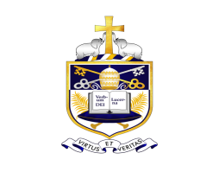

Name: ''''''''''''''''''''''''''''''''''''''''''''''''''''''''''''''''''''''''''''''''''''''' Class: '''''''''''''''''''' No: ''''''''''''''''''

**Part - I**

* **Select the most suitable answer.**
* **Mark $×$ in the provided MCQ answer sheet.**
* **All answers must be written in the Ink pen.**

01. ‘Vasana dineki meka’ (jdikd Èfkals fïl) song taken from the famous Nurthi,

i. Dutugemunu ii. Sri Wickrama

iii. Sakunthala iv. Vessanthara

02. Which of the following is a false statement when writing oriental notation?

i. Ma is the only note can be raised by adding a sharp.

ii. The lower octave is indicated by a dot above a note.

iii. A rest is indicated by +

iv. Flat is equivalent to Komala.

03. How many drums (maddalaya) are palyed together in the Nadagama?

i. 3 ii. 4 iii. 2 iv. 1

04. A non-rhythmical lyrical chant in Nadagam is known as,

i. Innisaya ii. Thanama iii. Dohora iv. Deepachandi

05. A non-rhythmical chant in Nurthi is,

i. Dohora ii. Innisaya iii. Uruttuwa iv. Pasan

06. The instruments used in Nurthi are,

i. Harmonium , Violin ii. Tamil drum , Nadeshwaran

iii. Esraj , Sitar iv. Maddalaya , Tabla

07. Which of the following is sung in quick rhythm in a Nadagam?

i. Dohora ii. Thanama iii. Uruttuwa iv. Pasan

08. Which of the following oriental note is equivalent to TE in Western notation?

i. Ri ii. Sa iii. Pa iv. Ni

09. Identify the clef.

|  |
| --- |
|  |
|  |
|  |
|  |

i. Treble ii. Bass

iii. Tenor iv. Alto

10. “Music of narrative or descriptive kind” is,

i. Opera ii. Oratorio iii. Programme music iv. Sonata

11. Who composed the 1812 overture?

i. Wagner ii. Tchaikovsky iii. Beethoven iv. Verdi

12. Which of the following work presents 14 variations by individual instrumental group?

i. Young persons guide to orchestra ii. Peter and the wolf

iii. Aida iv. Carnival of animals

13. It is known as the ‘festival overture’ and the sounds of cannon fire and the pealing of Cathedral bells heard,

i. William Tell Overture ii. 1812 Overture

iii. Magic flute iv. Lohengrin

14. A ‘spoonful of sugar’ is from the musical,

i. Mary poppins ii. My fair lady

iii. Sound of music iv. Wizard of OZ

15. In the Ascending form the 6th and 7th notes are raised in the scale of,

i. Harmonic minor ii. Melodic minor

iii. Major scale iv. Chromatic scale

16. Alto and Tenor clefs are called,

i. G clef ii. F clef iii. C clef iv. A clef

17. The Harmonius Blacksmith is an example of,

i. Binary form ii. Variation form

iii. Ternary form iv. Rondo form

18. Father of Nurthi is,

i. Philippu Singho ii. C. Don Bastian

iii. John De Silva iv. Dr. Ediriweera Sarachchandra

19. The first Sinhala Nadagam produced in Sri Lanka was by, who was a blacksmith by profession,

i. C. Don Bastian ii. Philippu Singho

iii. Charles Silva iv. Dr. Ediriweera Sarachchandra

20. The Nationality of Claude Debussy and Maurice Ravel,

i. German ii. Austrian iii. French iv. Italian

21. Bolero-one movement orchestral piece by,

i. Debussy ii. Ravel iii. Mendelssohn iv. Brahms

22. A set of piano pieces called songs without words by,

i. Wagner ii. Brahms iii. Mendelssohn iv. Ravel

23. A suitable time sign for a Cradle song is,

i. ${2 \atop 4}$ ii. iii. iv.

24. The scale which has $F^{\#} , C^{\#} , G^{\#} , D^{\#}$ four sharps as the key sign is,

i. B major ii. E major iii. A major iv. D major

25. Which one of these would be the sub-mediant of an ascending scale of G melodic minor,

i. D ii. E iii. iv.

26. Which of the following is the smallest distance of two notes on a keyboard,

i. Tone ii. Interval iii. Semitone iv. Octave

27. Which of the following is a concordant interval?

i. Minor 3rd ii. Major 2nd iii. Minor 7th iv. Augmented 3rd

28. Any sharps and flats occurring in a piece other than a key signature are called,

i. Natural ii. Accidentals iii. Slurs iv. Anacrusis

29. The total value of the given notes would be

i. 3 crochets ii. 4 crochets iii. 1 minim iv. Quaver

30. Which of the following composers lived the shortest life?

i. Mozart ii. Bach iii. Schubert iv. Beethoven

31. Which of the following is an instrumental composition?

i. Cantata ii. String quartet iii. Folk song iv. Lieder

32. Composer who was buried at West Minister Abbey?

i. Handel ii. Beethoven iii. Chopin iv. Mozart

33. Another name for left pedal is,

i. Sustaining pedal ii. Una corda

iii. Right pedal iv. Loud pedal

34. Which of the following are the open strings of the double bass?

i. EGBD ii. EADG iii. GDAE iv. CGDA

35. Which of the following instruments sounds the given note one octave higher?

i. Piccolo ii. Bassoon iii. Double Bassoon iv. French horn

36. Another name for Cor Anglais is,

i. English flute ii. English horn

iii. French horn iv. Haut Bois

37. Name the minor scale which has two sharps as the key signature.

i. G minor ii. B minor iii. $F^{\#}$ minor iv. D minor

38. Which of the following type of music has the voice and piano are treated as equal partner?

i. Oratorio ii. Lieder iii. Sonata iv. Solo

39. Another name for a Double Bassoon would be,

i. Contra Fagotto ii. Haut Bois

iii. Cor Anglais iv. Fagotto

40. Which of the following is a single reed instrument?

i. Oboe ii. Bassoon iii. Clarinet iv. Flute

**(40 Marks)**

**Part - II**

* 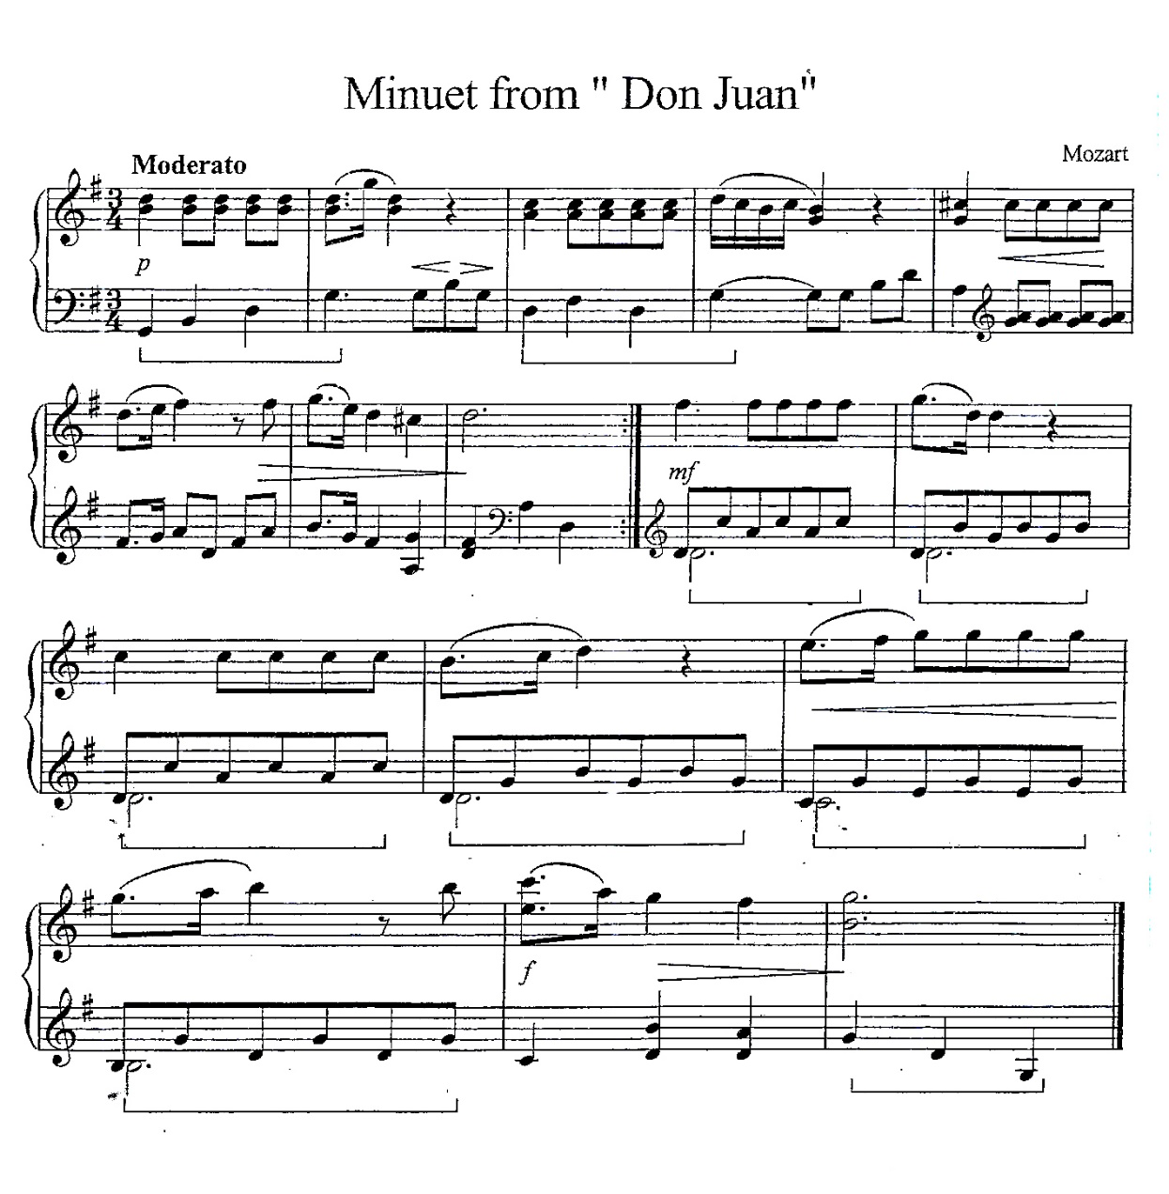**Question number one is compulsory.**
* **Select one question from A and one question from B.**

01. Questions are based on the short musical score minuet from “Don Juan”.

1. Write the English meaning of moderato. ___________________

2. What is the key signature. ___________________

3. What is the relative key sign. ___________________

4. Identify the time signature describe. ___________________

5. What is the corresponding compound time signature. ___________________

6. From which period is the composer? What is his nationality? ___________________

7. Name two contemporary composers of his period. ___________________

8. Identify two dynamic marks give the English meaning. ___________________

9. What is a minuet? ___________________

10. Does the piece end in the Tonic key? Yes / No. ___________________

11. Give the bar number where the key is changed. Name the key. ___________________

12. Name the interval in the last bar treble part top (Bar No, 16) which is a Harmonic interval.

___________________

**Section A**

* **Select One question.**

2A. Write the B melodic minor scale ascending form with key signature, mark semitones with slurs use the G clef write in minims.

|  |
| --- |
|  |
|  |
|  |
|  |

2B. Write F sharp Harmonic minor scale descending form without key signature using accidentals, mark semitones with slurs, use F clef write in crotchets.

|  |
| --- |
|  |
|  |
|  |
|  |

2C. Write the B major scale ascending form with key signature, mark semitones with slurs, use Treble clef in semibreves.

|  |
| --- |
|  |
|  |
|  |
|  |

2D. Name the following notes.

|  |  |  |  |  |  |
| --- | --- | --- | --- | --- | --- |
|  |  |  |  |  |  |
|  |  |  |  |  |  |
|  |  |  |  |  |  |
|  |  |  |  |  |  |

3A. Name 3 songs from the musicals.

1. Musical _______________________ Song _______________________

2. Musical _______________________ Song _______________________

3. Musical _______________________ Song _______________________

3B. Describe variation form write a example.

____________________________________________________________________________________________________________________________________________________

What is form in music.

__________________________________________________________________________

What are the other forms you learnt?

__________________________________________________________________________

3C. Define programme music give two examples with the composer.

______________________________________________________________________________________________________________________________________________________________________________________________________________________________

3D. Draw the Alto clef and M.C.

|  |
| --- |
|  |
|  |
|  |
|  |

Draw the Tenor clef and M.C.

|  |
| --- |
|  |
|  |
|  |
|  |

|  |  |  |
| --- | --- | --- |
|  |  |  |
|  |  |  |
|  |  |  |
|  |  |  |

4A. Name the following Intervals.

4B. Identify the distance is a tone or semitone.

|  |  |  |
| --- | --- | --- |
|  |  |  |
|  |  |  |
|  |  |  |
|  |  |  |

4C. Write the following triads.

|  |  |  |
| --- | --- | --- |
|  |  |  |
|  |  |  |
|  |  |  |
|  |  |  |

D minor tonic triad

with key sign root position

A minor Dominant triad first inversion

B major subdominant triad 2nd inversion

4D. Name three Nurthies by John De Silva

1. _____________________________________________________________________

2. _____________________________________________________________________ 3. _____________________________________________________________________

**Section B**

* **Select One question.**

5A. Describe Nurthi give a example.

______________________________________________________________________________________________________________________________________________________________________________________________________________________________

5B. Describe Nadagam give a example.

______________________________________________________________________________________________________________________________________________________________________________________________________________________________

5C. Name the drum used for Nadagam ______________________

Name the instruments used for Nurthi.

__________________________________________________________________________

5D. Dohora is found in Nadagam or Nurthi.

Inniya is found in Nurthi or Nadagam.

Vruttuwa is found in Nadagam or Nurthi underline the answer.

6A. Transpose the given melody an octave higher, so that it can be played on a recorder.

(Treble clef)

|  |  |  |  |  |
| --- | --- | --- | --- | --- |
|  |  |  |  |  |
|  |  |  |  |  |
|  |  |  |  |  |
|  |  |  |  |  |

|  |
| --- |
|  |
|  |
|  |
|  |

6B. Write the given melody in oriental notation.

|  |  |  |
| --- | --- | --- |
|  |  |  |
|  |  |  |
|  |  |  |
|  |  |  |

7A. Rewrite the given extract in the same pitch using the Tenor clef.

|  |  |
| --- | --- |
|  |  |
|  |  |
|  |  |
|  |  |

|  |
| --- |
|  |
|  |
|  |
|  |

7B. Name four Sri Lankan drums and describe various occasions where these drums are used.